Name:_________________ Class period:_________
The Story of Texas

Mexican Independence
Spain ruled the area now called Texas for ____________ years until the Mexicans rose up and won their independence. Mexicans were unhappy with Spanish rule because the best ___________ were saved for the _______________ and their ___________ were being used to fund wars in Europe. In _________, eleven years after the war had begun, Mexico won its independence. The area we now refer to as “Texas” became a ________________, or state, of Mexico. It was called Coahuila y ______________.
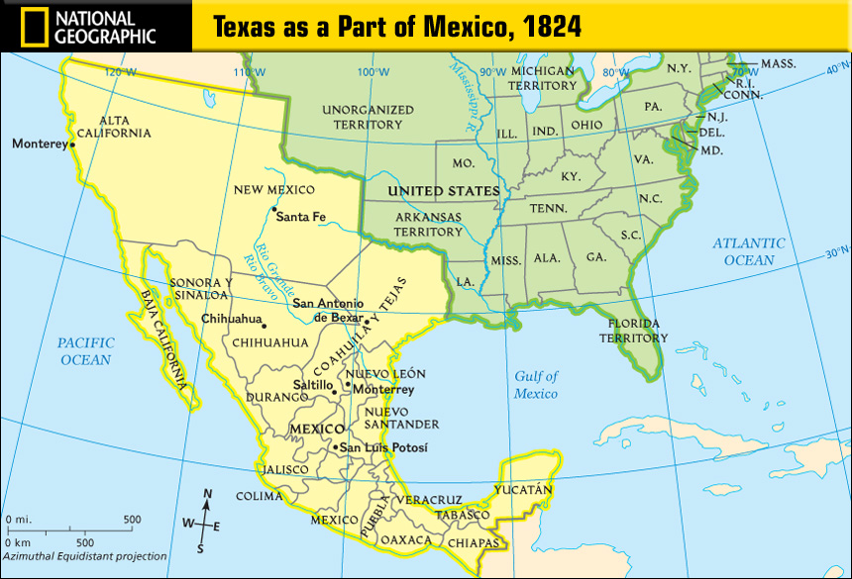

Anglos Come to Coahuila y Tejas
Before Mexico won its independence, an empresario named Moses Austin got permission from the _________________ government to bring other Anglos from the U.S. to live in Mexico. However, before he could bring any Anglos, Moses Austin died. After Mexico won its independence, his son, Stephen Austin continued his mission and brought settlers to Mexico. They were called The _____________________.
Mexico wanted the Anglos move to Coahuila y Tejas because they needed to jump-start their economy. The more citizens it has, the more taxes collected. The Anglos wanted to come to Coahuila y Tejas for three reasons: it was a chance to ___________________, the land was ____________, and it only cost _____________ an acre!
However, in order to move to Coahuila y Tejas, Anglos had to agree to several things. First, the only religion they were allowed to be was _______________. Second, they had to become Mexican citizens and third, follow all the ____________.

Road to the Revolution
In ___________, Mexico wrote a constitution for their new country. Unlike the U.S. Constitution, Anglos in Coahuila y Tejas did not have the freedom of ________________, ________________, or _________________ and could not own ____________. However, the Anglo Texans disobeyed many of these laws angering the Mexicans. Anglo Texans continued to keep their slaves and soon outnumber Mexicans themselves 5 to 1. Soon the Mexican government became suspicious of the Anglo Texans, fearing a revolt.
To keep the Texans under control the Mexican government issued the __________
_______________________. The Decree ended ____________________ from the U.S., created ______________ on things from the U.S., set up _________________ to keep Anglos from crossing the border, and ended all _________________, _______
__________, and ______________. These new laws increased tensions on both sides.
In response to the Decree of April 6, 1830, the Anglo Texans met at a ___________________ in 1832 and 1833. Here they made a list of demands of the Mexican government. They included:
1._____________________________ 2._______________________________
3._____________________________ 4._______________________________ ( NOT IN WORD
5._____________________________ 6._______________________________ BANK)
The Anglo Texans elected Stephen F. Austin to take the demands to the Santa Anna and the Mexican government. Santa Anna agreed to almost all of the requests except ___________________________________________________. This was perhaps the most important demand to the Anglo Texans. Although much of the Decree was taken back, they were still upset that this demand was not met and were further angered by Stephen Austin’s ___________________.

Word Bank
Mexican Independence
Tejas 300 taxes 1821 Province Jobs Spanish

Anglos Come to Coahuila y Tejas
Spanish Old 300 fertile 12.5 cents laws start over Catholic

Road to the Revolution
Arrest 1824 religion immigration speech slaves assembly
Decree of April 6, 1830 tariffs forts schools convention armies newspapers
Texas becoming its own state

