**Texas Revolution Battle Map**

**Directions:** Complete the map while paying close attention to the guide that follows:

**Part One:** Trace and label the following rivers in **blue**:

1. Red River 6. Colorado River

2. Rio Grande 7. San Antonio River

3. Sabine River 8. Trinity River

4. Neches River 9. Brazos River

5. Guadalupe River 10. Nueces River

**Part Two:** Put a **red star** on the following cities:

1. Goliad 4. Washington (on the Brazos River)

2. San Antonio 5. San Jacinto

3. Copono 6. Gonzales

**Part Three:** **Read** the following and **complete the directions** that follow.

**Battle of Gonzales -** After Stephen Austin returned from prison, he joined the War Party and supported Texan independence from Mexico. The war officially began on October 2, 1835 in Gonzales, Texas. Mexicans came to take a cannon they had lent the Texans to protect themselves from Native American attacks (as promised in the Reforms of 1834). However, the Texans refused to give up the cannon. They buried it until they could get reinforcements (more men). After digging it back up, the Texans put a flag on it that read, “Come and take it!” Mexican troops tried to reclaim the cannon but failed and went back to San Antonio where they were stationed. One Mexican died while no Texans died. This is the first battle of the Texas Revolution!

Directions:

1. Draw this symbol around the city of Gonzales.



2. Using a map pencil, draw an arrow representing Texan troop movement from Gonzales to Copano.

2. Write “T” next to the city of Gonzales to signify a Texan victory.

**Capture of Goliad –** On the night of October 9, 1835, a force of 50 Texans attacked the Mexican garrison at Goliad. A brief fight occurred and one Mexican soldier was killed. The rest of the garrison, outnumbered and surrounded, surrendered (gave up) to the Texans. The Texan victory at Goliad was important because it gave Texans confidence and much needed ammunition and arms (guns).

Directions:

Directions:

1. Draw this symbol around the city of Goliad.



2. Using a map pencil, draw an arrow representing Texan troop movement from Copano to Goliad.

3. Write “T” next to the city of Goliad to signify a Texan victory.

**Battle of Mission Concepcion** – Once a Texan army had been organized, plans were made to attack General Cos at San Antonio. Just on the outskirts of the city a battle occurred on October 28th. A force of 90 Texans led by James Fannin and James Bowie were attacked by 400 Mexican soldiers. In the battle Texans won a quick and clear victory, losing only one Texan soldier while Mexicans lost anywhere from fourteen to seventy soldiers.

Directions:

1. Draw this symbol just outside of San Antonio.

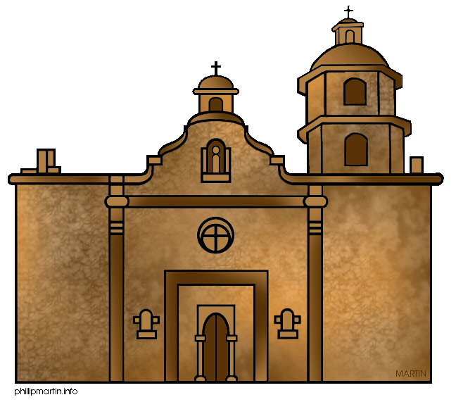

2. Using a map pencil, draw an arrow representing Texan troop movement from Goliad to Mission Concepcion.

3. Write “T” next to the mission to signify a Texan victory.

**The Grass Fight** – While part of the Texas Army remained at Mission Concepcion, Austin and the other Texans moved their camp to the Old Mill. On November 26, a scout named Erastus “Deaf” Smith, rode into camp with the news that Mexican soldiers were bringing horses and mules to San Antonio. About 100 Texans ambushed the Mexicans and captured their horses and mules, killing 3 Mexican soldiers. When the Texans opened the bags that supposedly held silver, they were greatly disappointed. The bags contained only grass.

Directions:

1. Draw this symbol just outside of San Antonio (away from the mission).



2. Write “T” next to the grass fight to signify a Texan victory.

**Battle of San Antonio –** After winning battles at Gonzales and Goliad, the Texans attacked Mexican troops at San Antonio on December 5, 1835. For the next four days, the battle raged for control of San Antonio. The Texans moved from house to house, slowly driving the Mexican forces back. On the fifth day of the attack, the Mexican forces were driven from the center of town and into the abandoned San Antonio de Valero mission, also known as the Alamo. On December 10, the Mexican army agreed to the terms demanded by the Texans and surrendered (gave up). 300 Texans had defeated 1,300 Mexicans! Twenty-one Texans and 150 Mexicans died in the battle.

After the Battle of San Antonio, the Texans went wild with celebration. Many believed the war was over and went home. However, Santa Anna had a different idea. He was gathered an army south of the Rio Grande to destroy the Texas rebellion. He would personally lead the attack. The Texans, cocky and unprepared, had no idea what was to come.

Directions:

1. Draw this symbol around the city of San Antonio.



2. Using a map pencil, draw an arrow, representing Texan troops movement from Goliad to San Antonio.

3. Write “T” next to the city of San Antonio to signify a Texan victory.

**Name:________________________ Date:_____________**

**Vanguard Texas History Period:___________**

**Questions:**

**Answer in complete sentences!**

1. **Who won the first five battles of the Texas Revolution?**
2. **Name the battles in order, write the dates they occurred, and number of people killed.**

|  |  |  |  |
| --- | --- | --- | --- |
| **Name of Battle** | **Date & Year** | **# of Mexicans Killed** | **# of Texans Killed** |
|  |  |  |  |
|  |  |  |  |
|  |  |  |  |
|  |  |  |  |
|  |  |  |  |

1. **How did these 5 victories affect the Texans? (hint: what were they thinking after they won)**

**4. What was on the flag at the Battle of Gonzales?**

**5. Why do you think the Texans were able to win these battles? (3 sentences)**

**6. How do you think Santa Anna and the Mexican Army felt after news of these battles? (3 sentences)**