Name ______________________________ Period ________________
Date _______________________________ Vanguard Texas History
Texas Declaration of Independence

Directions: Use OPTICS to analyze the following pictures below. Pay careful attention to details and DO NOT RUSH or you will miss something! You might want to look at the version on the website for a better quality image.

Signing the Texas Declaration of Independence

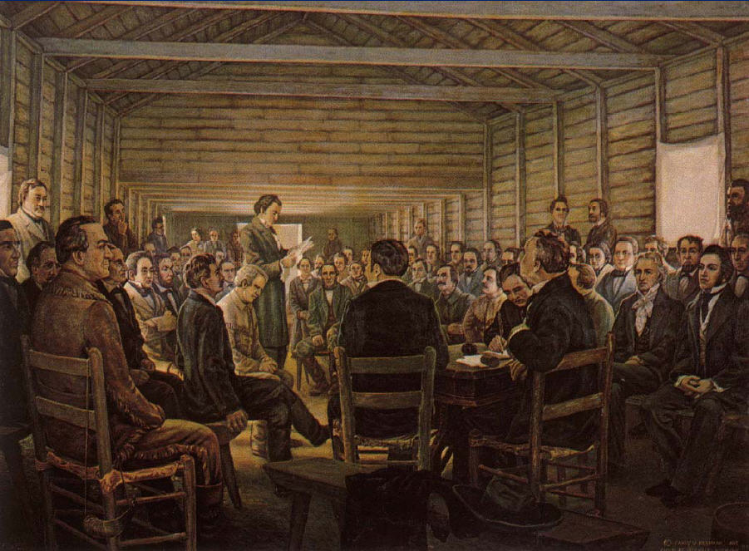Objects: List all the objects you see in this picture.

People: List all the people you see in this picture, general or specific.

Title and Time Period:
Title:
Time Period:

Inference: What do you think each part of the picture says about Texas History?
______________________________________________________________________________________________________________________________________________________________________________________________________________________________________________________________________________________________________

Conclusion: What is the message or the main idea? Summarize what the picture is telling you.
________________________________________________________________________________________________________________________________________________________________________________________________________________________________________________________________________________________________________________________________________________________________________________________________________ Summarize: Put it all together . __________________________________________________________________________________________________________________________________________________________________________________________________________________________________________________________________________________________________________________________________________________________________________________________________________________________________________________________________________________________________________

March 2, 1835
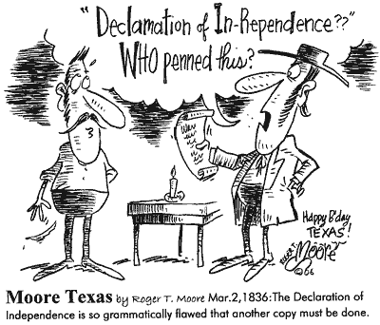
Objects: List all the objects you see in this picture.

People: List all the people you see in this picture, general or specific.

Title and Time Period:
Title:
Time Period:

Inference: What do you think each part of the picture says about Texas History?
______________________________________________________________________________________________________________________________________________________________________________________________________________________________________________________________________________________________________

Conclusion: What is the message or the main idea? Summarize what the picture is telling you.
________________________________________________________________________________________________________________________________________________________________________________________________________________________________________________________________________________________________________________________________________________________________________________________________________ Summarize: Put it all together . __________________________________________________________________________________________________________________________________________________________________________________________________________________________________________________________________________________________________________________________________________________________________________________________________________________________________________________________________________________________________________

