Name ____________________________________________ Class Period: ______________________
Date _____________________________________________ Subject: Blossom MYP/Vanguard Texas History

Cause/Effect and Human/Physical Characteristics

Directions: For each passage, underline the PHYSICAL characteristics in BLUE and the HUMAN characteristics in ORANGE. Then fill in the cause effect flow chart showing which type of characteristics caused the other. Be specific.

- Hurricane Ike - 2008
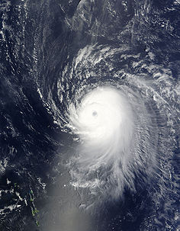

- Spindletop – 1901
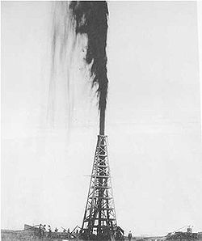

Hurricane Ike hit Texas in the fall of 2008 devastating the Houston-Galveston area. Gaining momentum over the Gulf of Mexico and then making its way to the mainland, Ike flattened homes, flooded the plains, cracked bridges, downed trees and power lines, and relocated thousands of people.

Did a physical or human characteristic cause this event? | Answer:
 | Explain:
Was the effect/result of this event a change in physical or human characteristics? | Answer:
 | Explain:

There had long been suspicions that oil might be under "Spindletop Hill” since the area was known for its sulfur springs. In 1901, Texans struck oil. It took 9 days to get the well under control and the rest was history. Beaumont’s population tripled in size in the next few months, from 10,000 to 30,000 and companies like Texaco and Gulf Oil were born.
Did a physical or human characteristic cause this event? | Answer:
 | Explain:
Was the effect/result of this event a change in physical or human characteristics? | Answer:
 | Explain:
- Mexican-American War
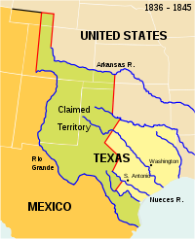

- Cattle Drives in West Texas
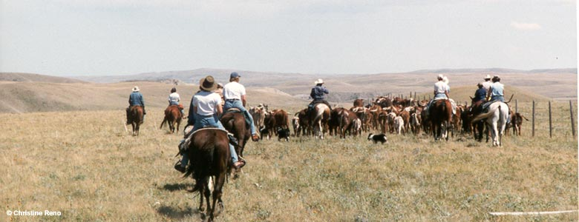

The Mexican-American war was an armed conflict between Mexico and the U.S. from 1846-1848. Mexico had owned Texas until Texas broke free in 1836. Soon thereafter, Texas decided to join the U.S. moving the border closer to Mexico. In denial, Mexico refused to recognize the new border between the U.S. and Mexico and war broke out. Homes and cities were destroyed in the fighting.

Did a physical or human characteristic cause this event? | Answer:
 | Explain:
Was the effect/result of this event a change in physical or human characteristics? | Answer:
 | Explain:

The era of the American cowboy lasted a brief period during the 1800’s. Much of the land in Texas was not suitable for agriculture due to inadequate rainfall, but the vast grasslands were ideal for cattle herding. Cowboys would drive herds of Longhorn cattle more than 1,000 miles to market (where the cattle was sold). Cattle drives came to an end with the invention of railroads, making walking to market unnecessary.
Did a physical or human characteristic cause this event? | Answer:
 | Explain:
Was the effect/result of this event a change in physical or human characteristics? | Answer:
 | Explain:

