Name _________________________________ Date _____________

Blossom MYP/Vanguard Texas History Period ____________

**OPTICS: Political Cartoons**

Directions: For each cartoon below use OPTICS to analyze it. Summaries should be a sentence or two.

**1) Drug War**

**O**bjects =

**P**eople =

**T**itle/**T**ime period =

**I**nferences =

**C**onclusions =

**S**ummarize =

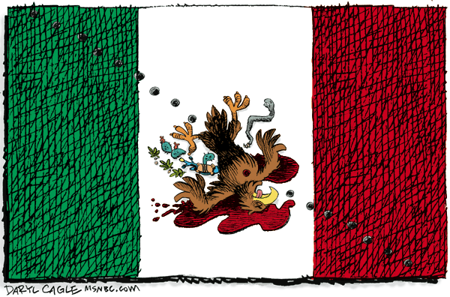

**2) Labor Day Jobs**

**O**bjects =

**P**eople =

**T**itle/**T**ime period =

**I**nferences =

**C**onclusions =

**S**ummarize =

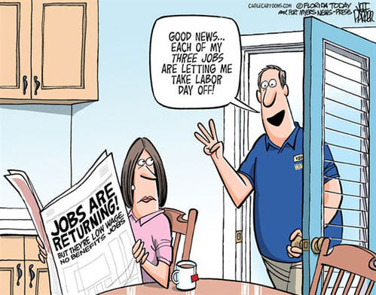

**3) Where’s the Beef?**

**O**bjects =

**P**eople =

**T**itle/**T**ime period =

**I**nferences =

**C**onclusions =

**S**ummarize =

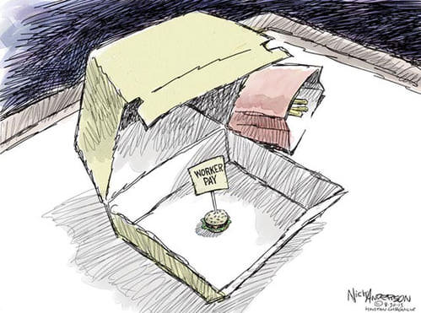

**4) Martin Luther King’s Dream**

**O**bjects =

**P**eople =

**T**itle/**T**ime period =

**I**nferences =

**C**onclusions =

**S**ummarize =

