Name: ________________________________________ Class: _____ Date: ___________________

Excretory System WebQuest

Section 1
Go to: http://www.fi.edu/learn/heart/systems/excretion.html
- The process of __________ involves finding and removing ________ materials produced by the_____.
- The primary organs of excretion are the _________, _________, and __________.
- _______ gases are carried by _________ traveling through the veins to the lungs where __________ takes place.
- Dead cells and__________ are removed from the body through the skin which is part of the ____________ system.
- Liquid waste is removed from the body through the _________.
- The kidneys are small (about 10 centimeters long) reddish-brown organs that are shaped like ________.
- During ___________, blood passes through the __________ in order to deposit used and unwanted __________, ___________, and a nitrogen-rich molecule called__________.
- The kidneys ___________ the wastes from the __________, forming a liquid called __________.
- The kidneys funnel the urine into the __________ along two separate tubes called __________.
- The bladder stores the urine until muscular ______________ force the urine out of the body through the ___________.
- Each day, your kidneys produce about ____________ of urine.
- This occurs through the process of _____________.
- If your kidneys are _____________ and not working properly, the buildup of toxic waste in your system will eventually lead to ___________.

Section 2
Go to: http://www.medindia.net/animation/anatomy_urinary.asp

- Each kidney is about the size of a human ____________.
- Label the diagram.
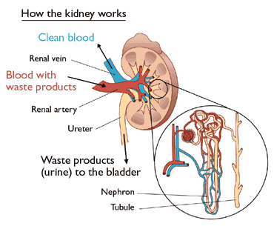

- The specialized unit of the kidney is called the nephron, and its function is to produce _____________ by filtering waste and extra fluid from the blood.
- Blood enters the kidney through the renal _____________ and passes into the nephron.
- The bulk of the filtering takes place in the _________________.
- The filtered wastes then travel through the tubule where the excess fluid is converted to ____________.
- The urine reaches the renal pelvis and passes into the ____________.
- Next, it enters the urinary ____________ to be stored until it is released via the ______________.
- Finally, the filtered blood leaves the kidney through the renal ______________.
Section 3
Go to: http://www.kidney.org/atoz/content/dialysisinfo.cfm

- What is dialysis?

- When is dialysis needed?
- What does dialysis do?

Section 4
Go to: http://medicalcenter.osu.edu/patientcare/healthcare_services/urinary_bladder_kidney/anatomy_urinary_system/pages/index.aspx

Label the diagram of the urinary system.
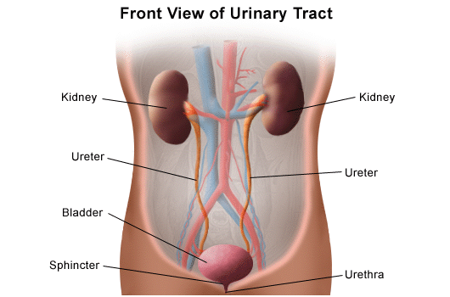

1.
5.

2.
6.

3.

7.
4.

What is the function of the following?:
- Kidneys - ________________________________________________________________________________________________________________________________________________________________________
- Ureters - ________________________________________________________________________________________________________________________________________________________________________
- Bladder - ________________________________________________________________________________________________________________________________________________________________________
- Urethra - ________________________________________________________________________________________________________________________________________________________________________
Section 5
URINALYSIS: http://www.nlm.nih.gov/medlineplus/ency/article/003579.htm
http://www.webmd.com/a-to-z-guides/urine-test
What does a urinalysis test for?

What does it mean if these things are found in your urine?
- Red Blood Cells
- Glucose
- Ketones
- Leukocytes/
White blood cells

