Name: _________________________ Date:_____________
Blossom MYP/Vanguard Texas History Class Period:______

Document Based Questions

Document Based Questions (DBQs) are used in history classes to determine if students can place primary sources within a historical time frame and form their own opinions by using evidence from the documents in an essay. This assignment will take you through the steps of the DBQ process. Remember to READ everything!

*Part 1: In part one you are given the BIG Question (the Thesis!) and the Historical Context. The first step is to read through both so you know what you are looking for in the primary source documents.

DBQ Essay Question
Is it necessary for the United States government to impose laws restricting the sale and possession of guns?

Historical Context
Following recent mass shootings, the conversation on enacting new gun control laws has swept the nation. Earlier this year, Congress failed to pass laws that would expand background checks on firearms sales and ban some semi-automatic weapons. People continue to debate the issue today.

*Part 2: In part two you are actually given the Primary Source Documents as well as DBQs for each of them. Analyze the document first (SOAPS or OPTICS), then answer the questions.

Document #1

“… the right of the people to keep and bear Arms, shall not be infringed.”
– The Second Amendment of the U.S. Constitution, ratified December 15, 1791
1) Why do you think this amendment was added to the Constitution in 1791? Is it relevant today? ___________________
____________________________________________________________________________________________________________________________________________________________________________________________________
2) Do you think every American citizen should still be entitled to this right? Would gun control laws be unconstitutional? __________________________________________________________________________________________________
____________________________________________________________________________________________________________________________________________________________________________________________________

Document #2

“Look, like the majority of Americans, I believe that the Second Amendment guarantees an individual a right to bear arms… I am also betting that the majority – the vast majority of responsible law-abiding gun owners – would be some of the first to say that we should be able to keep an irresponsible, law-breaking few from buying a weapon of war.”
– President Barack Obama, December 19, 2012, speaking at a White House news conference

1) What is President Obama’s point of view on gun control? ________________________________________________
__________________________________________________________________________________________________
__________________________________________________________________________________________________
2) How might Obama “keep an irresponsible, law-breaking few from buying a weapon of war?” Who is he referring to? __________________________________________________________________________________________________
____________________________________________________________________________________________________________________________________________________________________________________________________

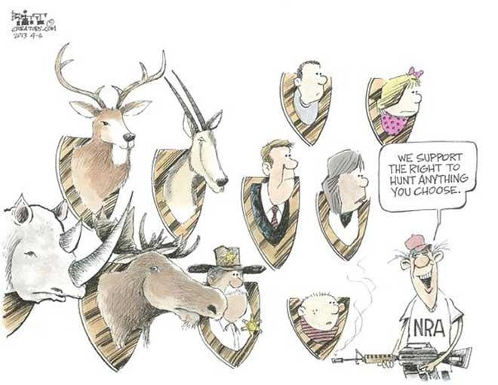
Document #3

1) How do you think this man views the Second Amendment? _______________________________________________
__________________________________________________________________________________________________
__________________________________________________________________________________________________
2) Why are humans portrayed as hunting trophies? What kinds of people do you see? _____________________________
____________________________________________________________________________________________________________________________________________________________________________________________________

Document #4

“The only thing that stops a bad guy with a gun is a good guy with a gun… but since when did the word ‘gun’ automatically become a bad word? A gun in the hands of a Secret Service agent protecting the President isn't a bad word. A gun in the hands of a soldier protecting the United States isn't a bad word. And when you hear the glass breaking in your living room at 3 a.m. and call 911, you won't be able to pray hard enough for a gun in the hands of a good guy to get there fast enough to protect you.”
– Wayne LaPierre, Executive Vice President of the National Rifle Association (NRA),
December 21, 2012, speaking at a news conference in Washington D.C.

1) What is Wayne LaPierre’s point of view on gun control? _________________________________________________
____________________________________________________________________________________________________________________________________________________________________________________________________
2) Do you think LaPierre would support extra background checks on gun sales? Why or why not? __________________
____________________________________________________________________________________________________________________________________________________________________________________________________

*Part 3: In part three you reread the BIG Question, and then start to brainstorm about how the documents connect to the question. You can create concept webs, an outline, whatever your English teacher taught you for Pre-Writing. During this process you should form your Own Opinion on the question. Do part 3 on another sheet of paper.

*Part 4: Now that you have formed your opinion and have analyzed the documents, you need a Topic Sentence to start your Essay.
Topic Sentence: ____________________________________________________________________________________
____________________________________________________________________________________________________________________________________________________________________________________________________

*Part 5: You now are ready to write your essay. Remember you must use the documents not just your opinion as evidence! Your Essay should include….
- Introduction – Discuss the Question\Thesis and include your Topic Sentence (3-5 sentences)
- 2 Body paragraphs- Discuss each document as evidence for your Answer and Opinion (5-8 sentences each). Use evidence to defend your opinion and to counter the opposing view point.
- Conclusion – Wrap up with your Main Idea again and any final points (3-5 sentences)

