Name: _________________________ Date: _____________
Blossom MYP/Vanguard Texas History Class Period: ______

Document Based Questions

Document Based Questions (DBQs) are used in history classes to determine if students can place primary sources within a historical time frame and form their own opinions by using evidence from the documents in an essay. This assignment will take you through the steps of the DBQ process. Remember to READ everything!

*Part 1: In part one you are given the BIG Question (the Thesis!) and the Historical Context. The first step is to read through both so you know what you are looking for in the primary source documents.

DBQ Essay Question
Was the United States Supreme Court’s ruling to strike down the Defense Of Marriage Act (DOMA) necessary in order to ensure the equal rights of all citizens under the law?

Historical Context
The United States has 12 states that officially recognize same-sex marriages. The Defense of Marriage Act (DOMA) barred the federal government from recognizing those unions. Edie Windsor, 84, sued the Internal Revenue Service (IRS) after she was denied her refund request for the $363,000 in federal estate taxes she paid after her spouse, Thea Spyer, died in 2009. On June 26, 2013 the Supreme Court ruled against DOMA. The decision ensures that federal benefits and protections will now be extended to legally married same-sex couples.

*Part 2: In part two you are actually given the Primary Source Documents as well as DBQs for each of them. Analyze the document first (SOAPS or OPTICS), then answer the questions.

Document #1
“The powers not delegated to the United States by the Constitution, nor prohibited by it to the States, are reserved to the States respectively, or to the people.”
– The Tenth Amendment of the U.S. Constitution, ratified December 15, 1791
1) Why do you think this amendment was added to the Constitution in 1791? Should states still have this much power today? ____________________________________________________________________________________________
____________________________________________________________________________________________________________________________________________________________________________________________________
2) The Constitution does not mention marriage, so do you think individual states should be allowed to decide on the legality of gay marriage? Why or why not? _______________________________________________________________
____________________________________________________________________________________________________________________________________________________________________________________________________

Document #2
“I applaud the Supreme Court’s decision to strike down the Defense of Marriage Act. This was discrimination enshrined in law. It treated loving, committed gay and lesbian couples as a separate and lesser class of people. The Supreme Court has righted that wrong, and our country is better off for it.”
– President Barack Obama, June 26, 2013, speaking from Air Force One in route to Africa

- What does President Obama mean by saying DOMA was “discrimination enshrined in law?” ___________________
_________________________________________________________________________________________________
_________________________________________________________________________________________________
- Why does President Obama feel “our country is better off” after the Supreme Court’s ruling? ___________________
_________________________________________________________________________________________________
_________________________________________________________________________________________________

Document #3
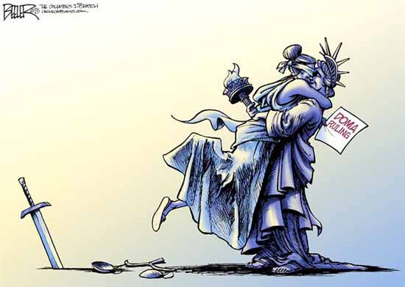

1) Who do the two women represent? ___________________________________________________________________
__________________________________________________________________________________________________
__________________________________________________________________________________________________
2) What is the significance of the embrace? ______________________________________________________________
____________________________________________________________________________________________________________________________________________________________________________________________________

Document #4

“It’s imperative that Congress continue to preserve the right of states to protect true marriage and refuse to recognize faux marriages performed in other states or countries.”
– Brian Brown, Executive Director of the National Organization for Marriage,
June 26, 2013, immediately following the DOMA ruling

1) What is his point of view on the DOMA ruling? _______________________________________________________
__________________________________________________________________________________________________
__________________________________________________________________________________________
2) What does he mean by saying “protect true marriage?” ___________________________________________________
__________________________________________________________________________________________________
__________________________________________________________________________________________________

*Part 3: In part three you reread the BIG Question, and then start to brainstorm about how the documents connect to the question. You can create concept webs, an outline, whatever your English teacher taught you for Pre-Writing. During this process you should form your Own Opinion on the question. Do part 3 on another sheet of paper.

*Part 4: Now that you have formed your opinion and have analyzed the documents, you need a Topic Sentence to start your Essay.
Topic Sentence: ____________________________________________________________________________________
____________________________________________________________________________________________________________________________________________________________________________________________________

*Part 5: You now are ready to write your essay. Remember you must use the documents not just your opinion as evidence! Your Essay should include….
- Introduction – Discuss the Question\Thesis and include your Topic Sentence (3-5 sentences)
- 2 Body paragraphs- Discuss each document as evidence for your Answer and Opinion (5-8 sentences each). Use evidence to defend your opinion and to counter the opposing view point.
- Conclusion – Wrap up with your Main Idea again and any final points (3-5 sentences)

