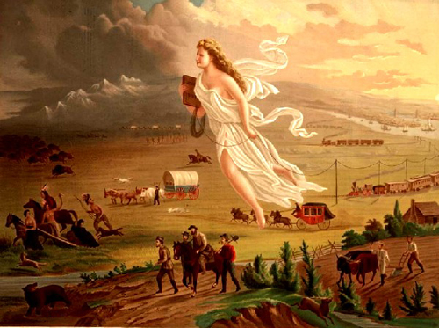
American Progress – John Gast (1872)
American Progress Notes
Manifest Destiny – ____________________________________________________________________________________________________________
________________________________________________________________________________________________________________________
Westward Expansion – ________________________________________________________________________________________________________
________________________________________________________________________________________________________________________
Reasons for Manifest Destiny
- _____________________________________________ first coined the phrase in Democratic Review, in ______________________________.
- Reasons for belief in Manifest Destiny:
- Sincere belief in __________________________ and ____________________________.
- Idealized view of U.S. as __________________________ for others.
      - Ideology intertwined with _________________________ and ____________________________[extending your country’s power] ideas about American Indians and Mexicans.
      - Tied to religion “________________________________________________”
- Less separation of ________________________ and ________________________________________during this time period.
- ___________________during this time period.

