Don’t be a Hater! Be an Abolitionist!

William Lloyd Garrison
When did he live?

Was he a slave?

What was he known for?

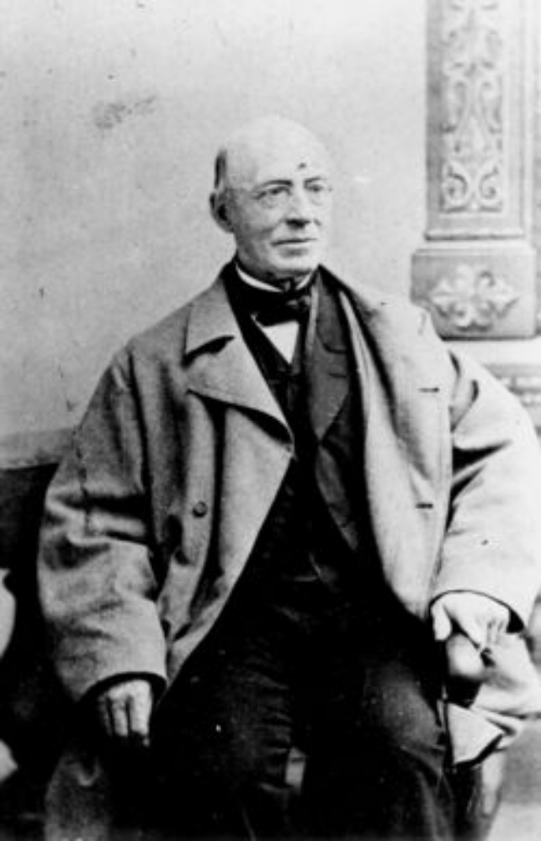

Sojourner Truth
When did she live?

Was she a slave?

What was she known for?

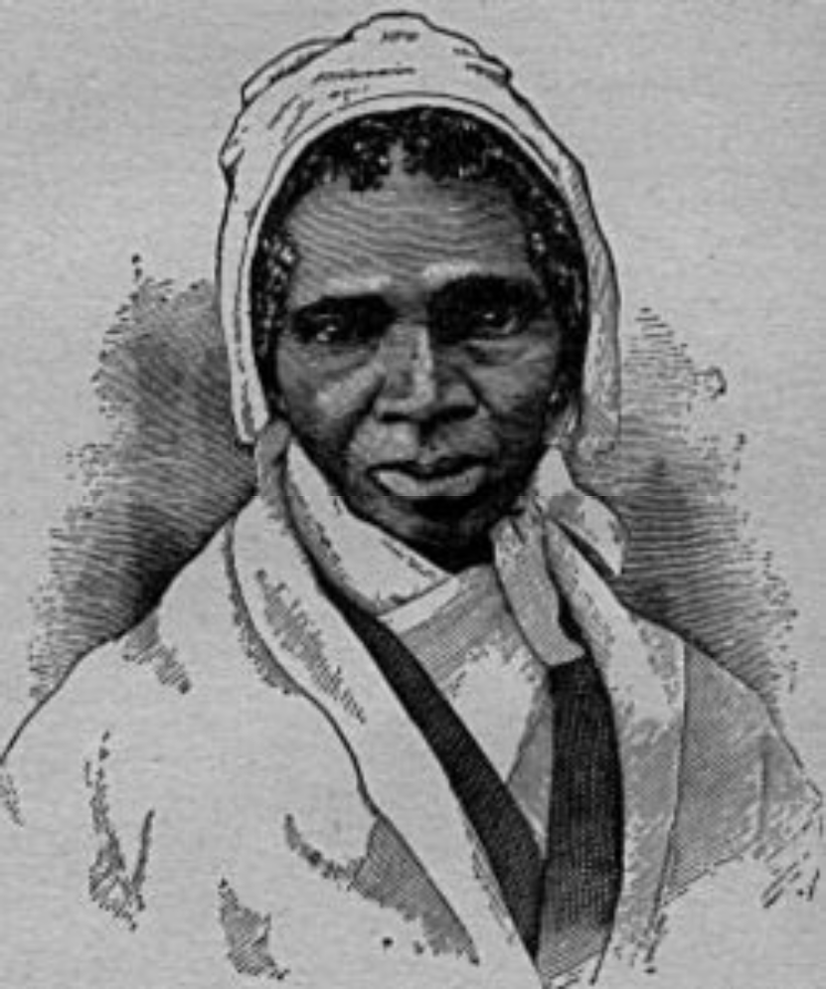

Nat Turner
When did he live?

Was he a slave?

What was he known for?

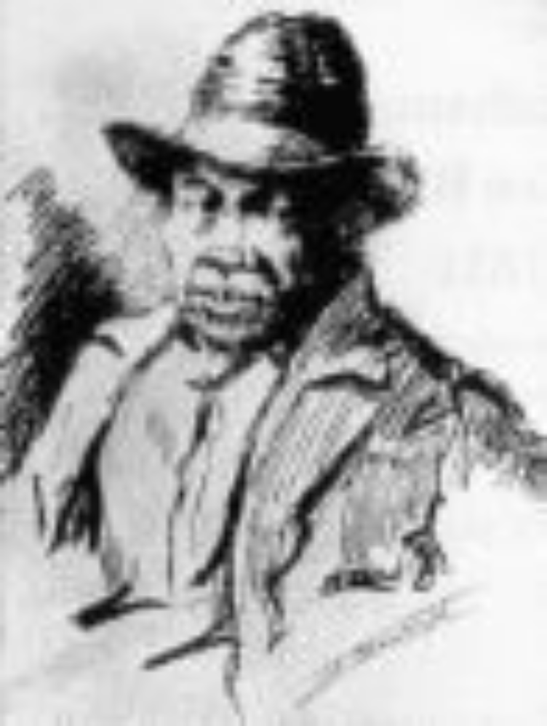

Harriet Tubman
When did she live?

Was she a slave?

What was she known for?

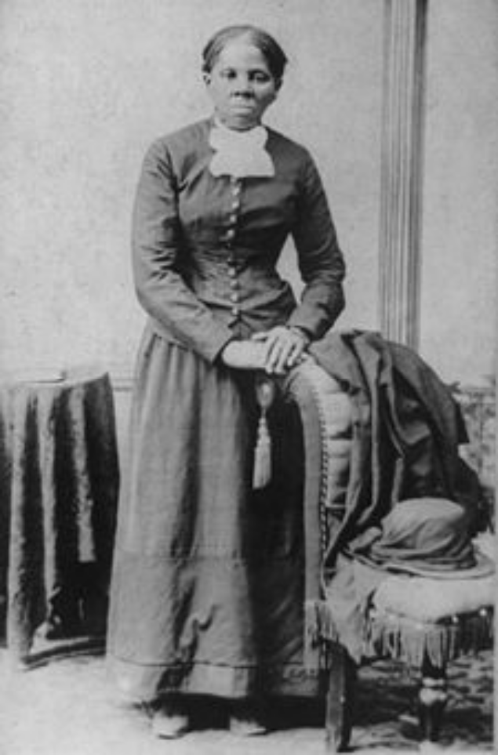
When did he live?

Was he a slave?

What was he known for?

Frederick Douglass
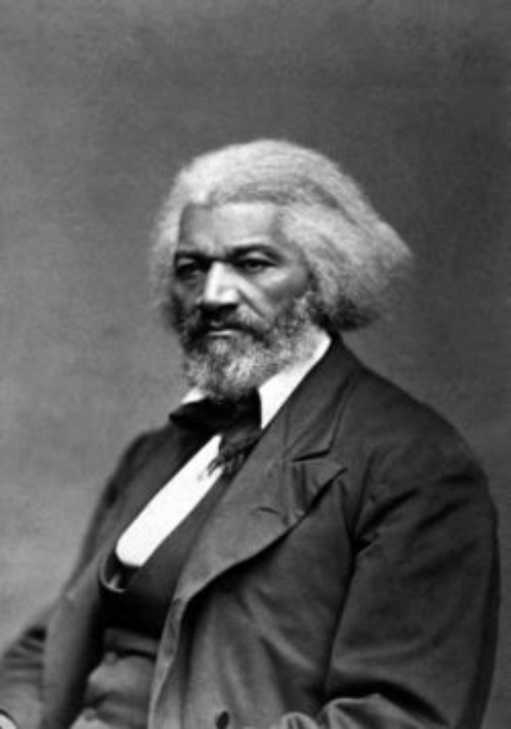
When did he live?

Was he a slave?

What was he known for?

John Brown
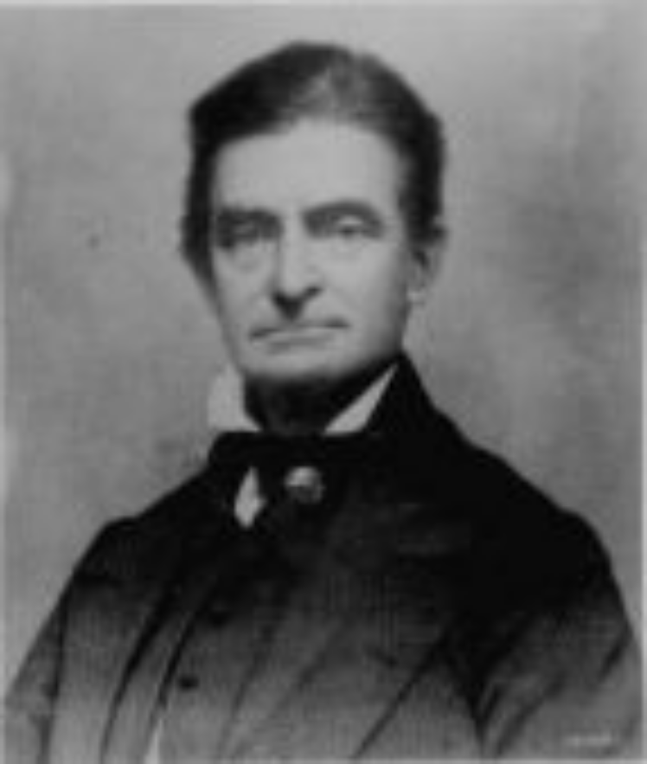

Harriet Beecher Stowe
When did she live?

Was she a slave?

What was she known for?

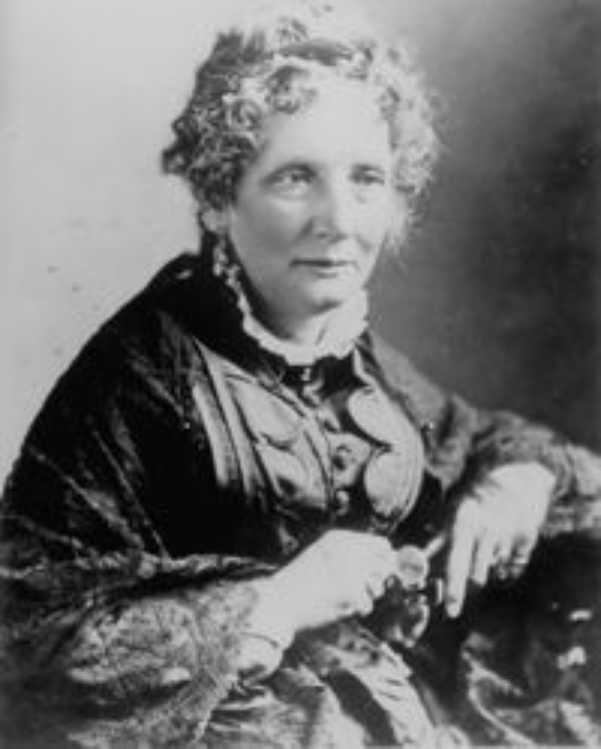

Sojourner Truth (1797-1883)
My real name is Isabella Baumfree. I was born into slavery in New York but escaped in 1826 and become officially free in 1827. I worked for the abolition of slavery and for women’s rights. I am best known for my speech, “Ain't I a Woman?” and for fighting to desegregate public transportation.

Nat Turner (1800-1831)
I am a slave who taught myself how to read and write. In 1831, I led a group of slaves on a violent rampage against whites in Virginia. My followers and I killed about 60 whites before we were caught. Fifty-five of us blacks were executed for our part in this rebellion. The whites retaliated by killing more than 200 blacks after our executions.

Harriet Tubman (1820-1913)
My nickname is “Black Moses” because I led a lot of blacks to freedom on the Underground Railroad. I was a slave myself in Maryland but in 1849, I escaped to the North through the Underground Railroad. I made 19 trips back into the South during the 1850’s to help other enslaved people escape, risking my own freedom. I helped more than 300 people escape on the Underground Railroad and am, therefore, the most famous “conductor.”

Frederick Douglass (1818-1895)
I am the most widely known African American abolitionist. I was born into slavery in Maryland, taught himself how to read and write, and escaped slavery in 1838. I am a great speaker and traveled all over spreading my antislavery views. I also edited an abolitionist newspaper called the North Star and in 1847, I bought my freedom from my owner.

John Brown (1800-1859)
I am a white abolitionist and believe God chose me to end slavery. In 1859, I led a violent rebellion called the Raid on Harpers Ferry. Nineteen men, both white and black, including myself, raided a storage place for weapons and ammunition. We were trying to get weapons to arm slaves but were caught. I was convicted of treason and hung. Some abolitionists did not support my use of violence while others considered me a hero. Nonetheless, the nation was in uproar when I was executed.

Harriet Beecher Stowe (1811-1896)
I am a white writer and abolitionist in Massachusetts. In 1852, I wrote my most famous work about the evils of slavery called Uncle Tom’s Cabin. It sold over 300,000 copies in the first year. It was a best seller in the North and banned in the South. Abraham Lincoln said this to me about Uncle Tom’s Cabin, “You wrote the book that started this Great War.”

William Lloyd Garrison (1805-1879)
I am a prominent white abolitionist, journalist, and social reformer. I started my own abolitionist newspaper in Boston in 1831 called The Liberator and founded the American Antislavery Society in 1833. I was one of the first white abolitionists to call for the immediate freeing of slaves.

Sojourner Truth (1797-1883)
My real name is Isabella Baumfree. I was born into slavery in New York but escaped in 1826 and become officially free in 1827. I worked for the abolition of slavery and for women’s rights. I am best known for my speech, “Ain't I a Woman?” and for fighting to desegregate public transportation.
Nat Turner (1800-1831)
I am a slave who taught myself how to read and write. In 1831, I led a group of slaves on a violent rampage against whites in Virginia. My followers and I killed about 60 whites before we were caught. Fifty-five of us blacks were executed for our part in this rebellion. The whites retaliated by killing more than 200 blacks after our executions.

Harriet Tubman (1820-1913)
My nickname is “Black Moses” because I led a lot of blacks to freedom on the Underground Railroad. I was a slave myself in Maryland but in 1849, I escaped to the North through the Underground Railroad. I made 19 trips back into the South during the 1850’s to help other enslaved people escape, risking my own freedom. I helped more than 300 people escape on the Underground Railroad and am, therefore, the most famous “conductor.”

Frederick Douglass (1818-1895)
I am the most widely known African American abolitionist. I was born into slavery in Maryland, taught himself how to read and write, and escaped slavery in 1838. I am a great speaker and traveled all over spreading my antislavery views. I also edited an abolitionist newspaper called the North Star and in 1847, I bought my freedom from my owner.

John Brown (1800-1859)
I am a white abolitionist and believe God chose me to end slavery. In 1859, I led a violent rebellion called the Raid on Harpers Ferry. Nineteen men, both white and black, including myself, raided a storage place for weapons and ammunition. We were trying to get weapons to arm slaves but were caught. I was convicted of treason and hung. Some abolitionists did not support my use of violence while others considered me a hero. Nonetheless, the nation was in uproar when I was executed.

Harriet Beecher Stowe (1811-1896)
Harriet Beecher Stowe was a white writer and abolitionist in Massachusetts. In 1852, she wrote her most famous work about the evils of slavery called Uncle Tom’s Cabin. Her book sold over 300,000 copies in the first year. It was a best seller in the North and banned in the South. Abraham Lincoln was quote saying this to Stowe about Uncle Tom’s Cabin, “You wrote the book that started this Great War.”
William Lloyd Garrison (1805-1879)
I am a prominent white abolitionist, journalist, and social reformer. I started my own abolitionist newspaper in Boston in 1831 called The Liberator and founded the American Antislavery Society in 1833. I was one of the first white abolitionists to call for the immediate freeing of slaves.

